**SOP For NLA issue in Azure windows VM**

**Error Snip:**

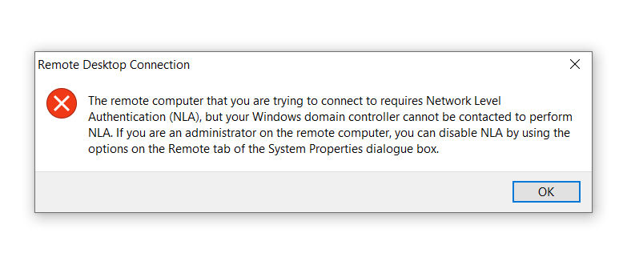

Please go to the run command and choose RunPowerShellScript

Then copy paste the below mentioned script

**Write-Output 'Configuring registry to disable Network Level Authentication (NLA).'**

**$path = 'HKLM:\SYSTEM\CurrentControlSet\Control\Terminal Server\WinStations\RDP-Tcp'**

**Set-ItemProperty -Path $path -Name SecurityLayer -Type DWord -Value 2**

**Set-ItemProperty -Path $path -Name UserAuthentication -Type DWord -Value 1**

**Set-ItemProperty -Path $path -Name fAllowSecProtocolNegotiation -Type DWord -Value 1**

**Write-Output 'Restart the VM for the change to take effect.'**

After executing the script, It will take some time to get output.

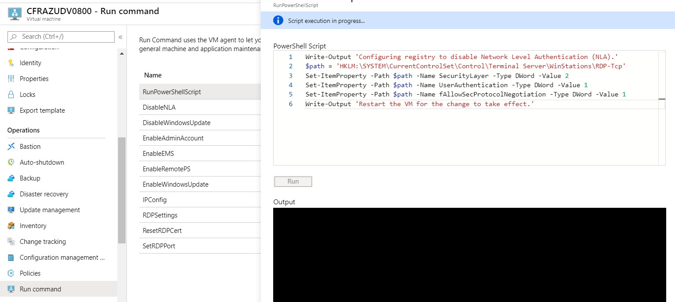

The Output should like this

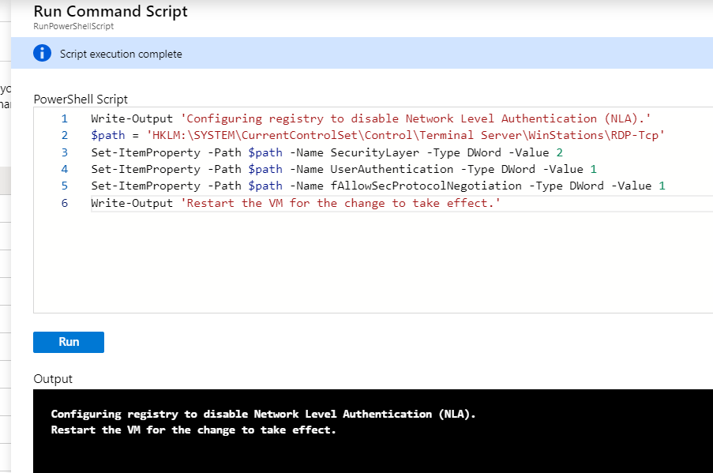

Then Please restart the VM via portal.